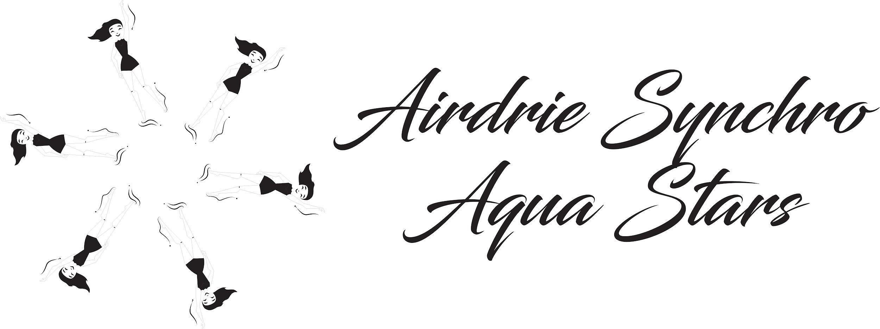

Airdrie Synchro Aqua Stars Emergency Treatment Authorization Form

In the event of any emergency involving _______________________ where I (parent and/or guardian) cannot be reached at any of the phone numbers on file, I (we) authorize the Airdrie Synchro Aqua Stars coach or the aid to seek medical attention for the noted swimmer. I understand that it is my responsibility to provide a new Emergency Medical Treatment Authorization Form when the information herein changes. This permission is effective from September 8, 2025 until May 15, 2026 while the swimmer is under the supervision of the coach.

Date:________________________

Name of parent/guardian:____________________ Cell/Contact #________________________

Signature of parent/guardian: _______________________

Swimmer name:___________________________________

Emergency Contact::

Name and Relation:_____________________________

Phone numbers of emergency contact:_________________________

Doctor’s name:______________________ Doctor’s address:__________________________

Swimmer’s Alberta Health Care Number:__________________________

Does the swimmer have any medical conditions/allergies which should be known yes/no.

If so, please provide details:______________________________

List any medications currently being taken:_______________________________

